## Mengzhou Yao

## 08/29/2020

## IT FDN 110 A

## Assignment08

<https://github.com/myao3/IntroToProg-Python-Mod08>

**Product name and price Script**

**Introduction**

In this assignment 08, the script will display a list of menu to the user: Show current data; Add a new item; Save Data to File; Exit Program under class.

**Procedure**

Creating Script

In the Class product, we will add the private attribute self.__product_name and self__product_price. Under the @property, we get the value for product name and set if the value of product name equal to number, it will cause the error(Names cannot be number); we also get the value for product price and set if value of product price is less than zero, it will cause the error (The price must be greater than zero).

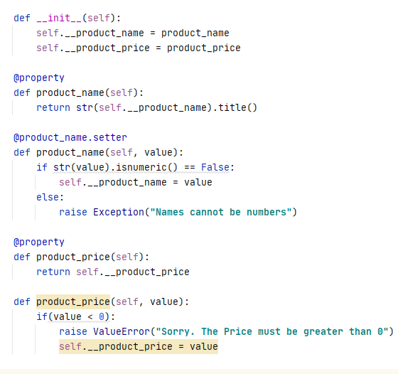

*Figure 1: the screenshot of the class Product in the PyCharm program*

In the class FileProcessor, we create two objects with Class product, form them into lstOfProductObjects and save them to “products.txt” under save_data_to_file def. Then we read data from “products.txt” and append to lstOfProductObjects under read_data_to_file def.

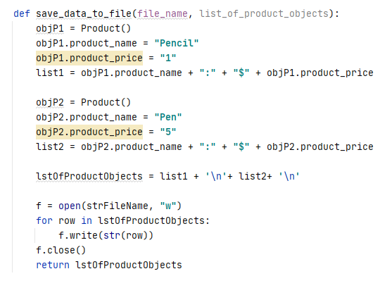

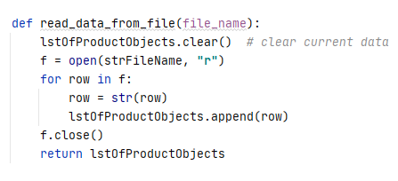

*Figure 2: the screenshot of the Class FileProcessor in the PyCharm program*

In the Class IO, we create the menu of choice under price_menu def; let the user input a new product name and price and append it to lstOfProductObjects under input_new_product_and_price def; let the user input the menu choice under input_menu_choice def; we save the current data(lstOfProductObjects) to “products.txt” under write_data_to_file def; We display the current data(lstOfProductObjects) under the print_current_list def.

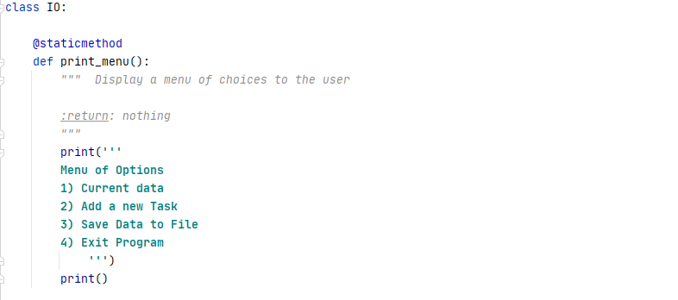

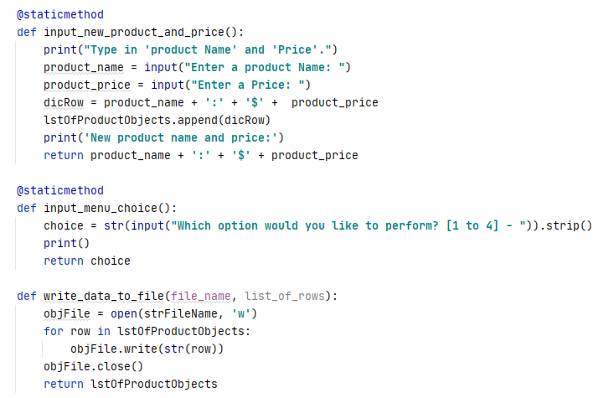

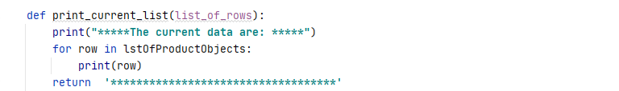

*Figure 3 : the screenshot of the main body in the PyCharm program*

We run save_data_to_file function to save the data to “products.txt” and run read_data_to_file function to load data from “products.txt” before main body.

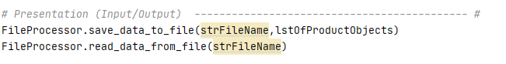

*Figure 4 : the screenshot of the presentation in the PyCharm program*

In the main body, first we show the menu and let user to input choice; there are four options(1 to 4): Current data(we display lstOfProductObjects) ; Add a new Task(user input product name and price by input_new_product_name_and_price function); Save Data to File(we write the current data to “products.txt”); Exit Program. If user input is other than “1 to 4”, the script display a error message(Oops! That was no valid number. Try again...).

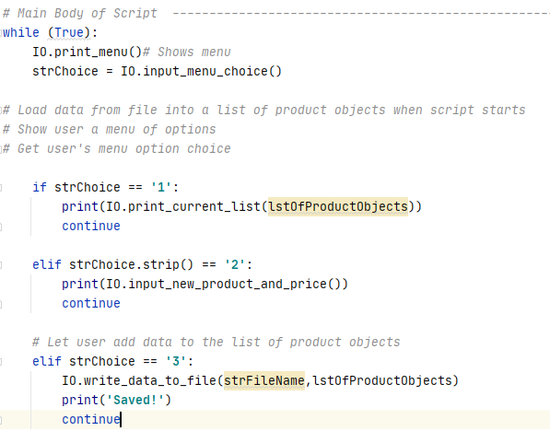

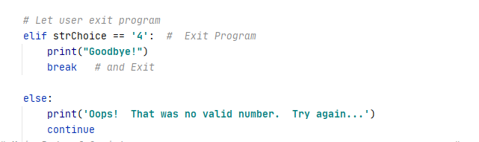

*Figure 5 : the screenshot of the main body in the PyCharm program*

Saving the script

I create a folder in C:\_PythonClass called “Assignment08” and save my script as “Assigment08”.

Running the script

I open PyCharm in search windows and open the “Assignment08” to run module, I choose “1” to display the current data. I choose “2” to add new product name and its price. I choose “3” to sav data to file. I choose “4” to exit program.

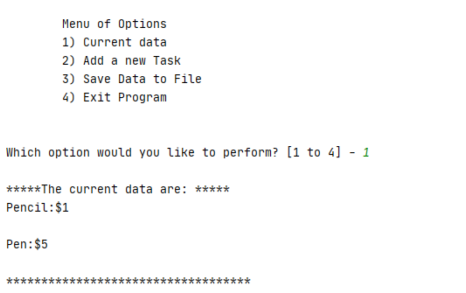

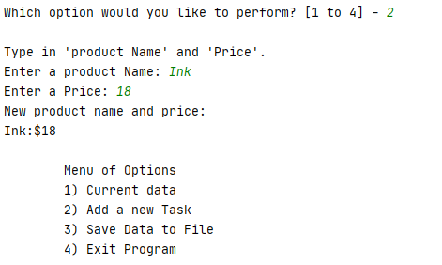

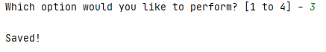

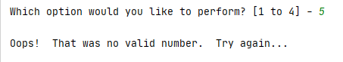

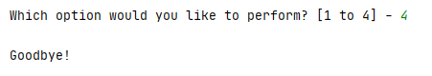

*Figure 6: the screenshot of running the script in the PyCharm program*

Verifying data in the txt.file

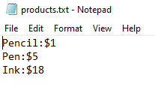

*Figure 7: the screenshot of verifying data in the txt file*

**Summary**

Using the module 08 video, notes, textbook, and supplemental video, I was able to understand the pseudo-code and add code in the to do list script by letting user to display the data, enter the data, save the data and exit the program.